Studio PDR Planning Worksheet

Learning outcome 1
Select and apply industry-standard tools and processes to solve non-trivial problems in a team environment.

Objectives:
- Select and apply Scrum techniques proficiently to align to the Agile Principles wherever possible.
- Demonstrate professionalism in your use of project management and communication tools.
- Employ leadership in a flat-structured, cross-functional team (e.g. leading by example, champion role).

Learning outcome 2
Analyse and manage development challenges to create production-quality outputs.

Objectives:
- Analyse user requirements and contribute regularly to development of new product features that meet those requirements.
- Participate regularly in code/solution review to ensure high-quality outputs
- Conduct self-directed research to contribute regularly to all technical aspects of the project, including:
  - deployment and CI/CD,
  - quality assurance and testing,
  - security, and
  - user experience.

Name: Artemis Churcher
Date of scheduled PDR meeting: Mid-semester
Discussed with:

Please complete the reflective section below to help give us the context for your evidence.

What are your personal goals and objectives in addition to the course objectives?
This could be for Studio, BIT or general career progression
What has gone well this semester? What are your strengths?
What could have gone better and how? What would you do differently next time?
If you could replay the semester over again, what improvements would you make?
What are the next steps to take? What is your plan for further self-development?
What barriers to your success exist? How do you plan to deal with them?
What is not clear or is uncertain?
In Studio, for BIT, at Polytech etc

Instructions
For each objective, provide enough evidence to show that you have met the requirements.

For every objective include:
- at least one image (if available) for quick reference,
- an analysis of how the evidence proves you’ve met the objective, and
- links to any more evidence that exists for that objective.

  - Select and apply Scrum techniques proficiently to align to the Agile Principles wherever possible.

Evidence guidance: Are you attending stand-up meetings? What Scrum events and artefacts can you show? How do your team’s processes align to the Agile Principles? What suggestions have you personally made to improve your team performance? Are you applying techniques from previous semesters to solve performance problems (e.g. user stories -> user-centric focus; story points -> effective Sprint planning, etc)?

I think having (actual) daily scrum meetings has really improved cohesion within the group. We’ve tried to have at least one meeting daily and where we’ve missed a day (once or twice) we extended the amount of time during the next meeting to assist with problems and discuss each issue more.

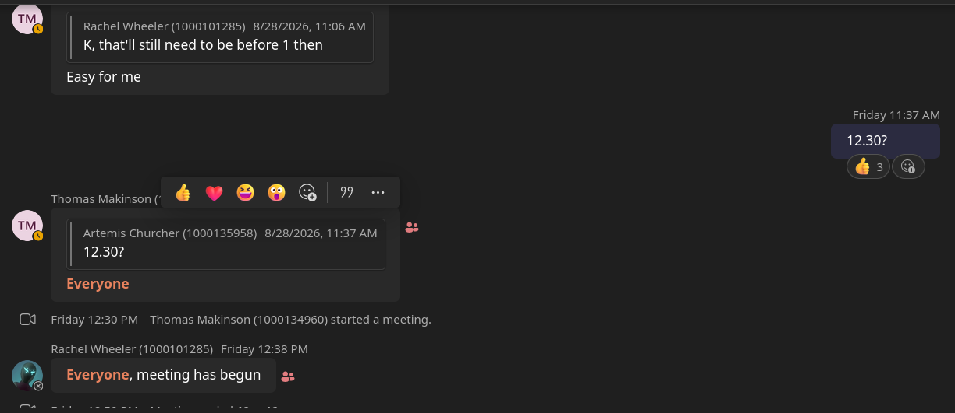

A teams discussion on when to have our virtual scrum ~ but most meeting times are discussed in person and the meetings themselves are usually done in person too.

I’ve assisted Thomas in setting up the GitHub resources to assist in agile workflow, such as migrating user stories from the previous project and documenting comments made by our product owner when we meet with them.

We’ve also modified the templates for a few of our operations over the last few sprints to help in our planning and reviews of code submitted.
I’ve been designated to spearhead the understanding of story points as I am from the minority of members who have used story points and velocity in a previous project. I’m eager to start implementing said practice over the next few sprints.

  - Demonstrate professionalism in your use of project management and communication tools.

Evidence guidance: Are you writing thorough descriptions for your issues and pull requests? Do you always update the status of your tickets in a timely manner? Do you use all the features of GitHub to keep everything well-organised? Do you respond to comments from your team mates in a timely manner and with professional tone?

Unlike previous projects, I’ve started using user stories as the driving force for development which has helped in constructing issues and acceptance criteria.

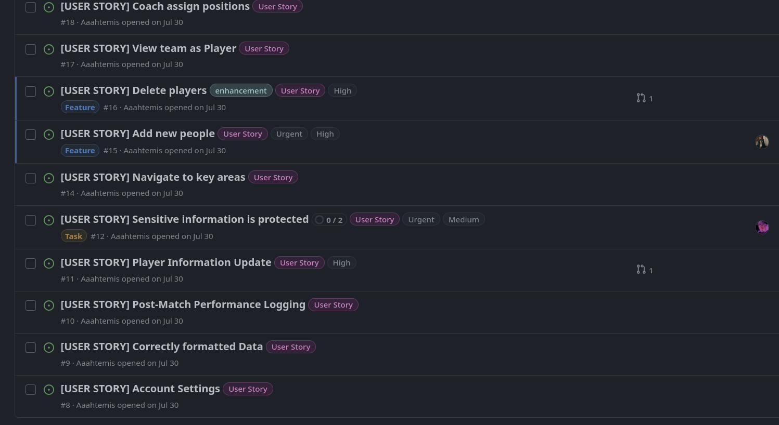
A list of some user stories I’ve opened.
https://github.com/BIT-Studio-4/ProjectOption1/issues?q=is%3Aissue%20state%3Aopen%20label%3A%22User%20Story%22

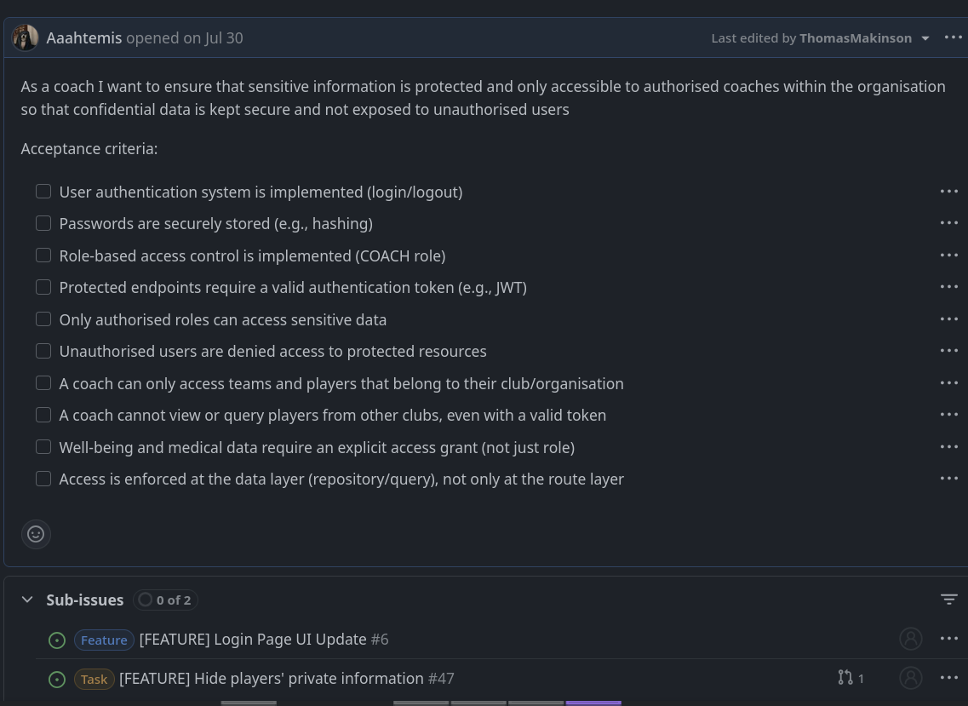
A user story that contains acceptance criteria and sub-issues to be resolved.
https://github.com/BIT-Studio-4/ProjectOption1/issues/12

I moved the user stories and related issues over to the new repo at the start and I’ve been adding user stories based on our feedback from the product owner and my team role to champion security.

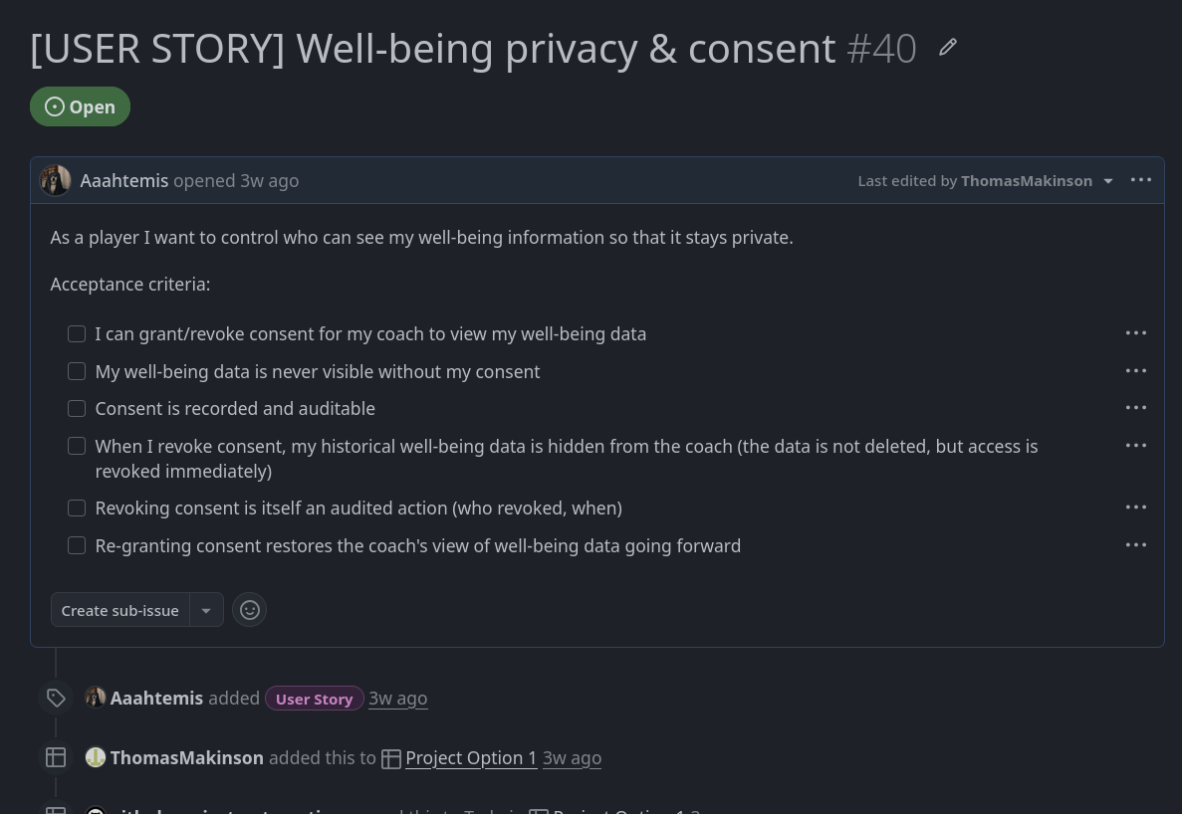
Consent as a security concern.
https://github.com/BIT-Studio-4/ProjectOption1/issues/40

  - Employ leadership in a flat-structured, cross-functional team (e.g. leading by example, champion role).

Evidence guidance: Have you identified problems to be solved in the way your team approaches the aspect you are champion of? Do you lead by example to improve on issues in your team’s performance (e.g. regular communication)? Do you take ownership of challenges and lead the team through the problem-solving process?

I’ve consistently brought up security concerns with the group on topics such as login functionality and how human error can interfere with safe practice.
(Most of which are in person and no evidence has been recorded)

During the security audit I found many issues with the security of the site and api access. Looking through the 10 common vulnerabilities, 6 concerns were relevant to our project and every single one failed miserably. I’ve also used security testing software (ZAP) to probe the working site and received 7 errors from that.
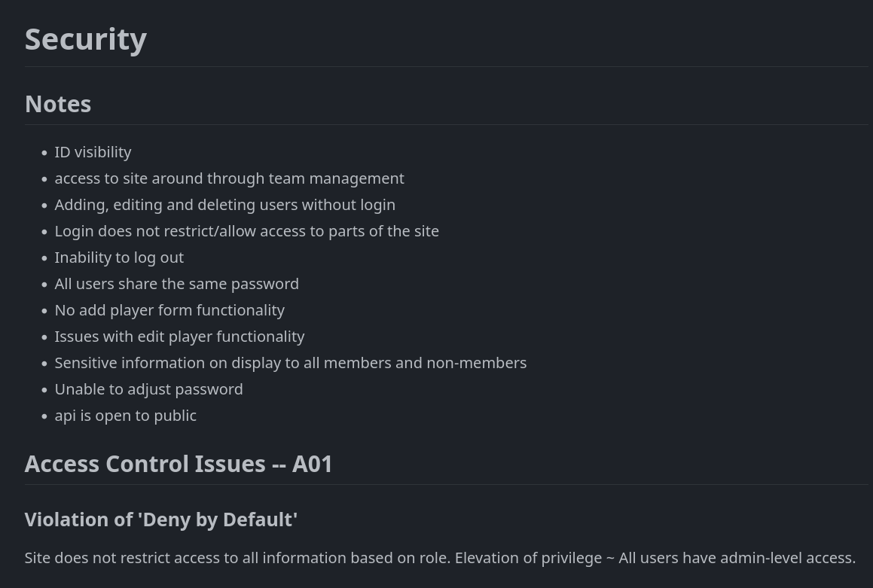
https://github.com/BIT-Studio-4/ProjectOption1/wiki/Audits#security

  - Analyse user requirements and contribute regularly to development of new product features

Evidence guidance: Have you met with the Product Owner and written User Stories? Have you broken the User Stories down into tickets in the issues list? Have you opened Pull Requests for your assigned tickets and written a description that analyses the problem to be solved, identifies any potential challenges and outlines the approach you intend to take? Do you contribute commits over several days during every Sprint?

We’ve discussed with the product owner a bit each sprint, trying to work through what we need in our app and settled on making the simplest possible working version. CRUD isn’t fully implemented and so we’re able to refactor the site to make the new working idea feasible. Because of this, I’ve reworked the ERD to make it more efficient and simple for adjusting the data from the front end whilst cutting out unnecessary values.

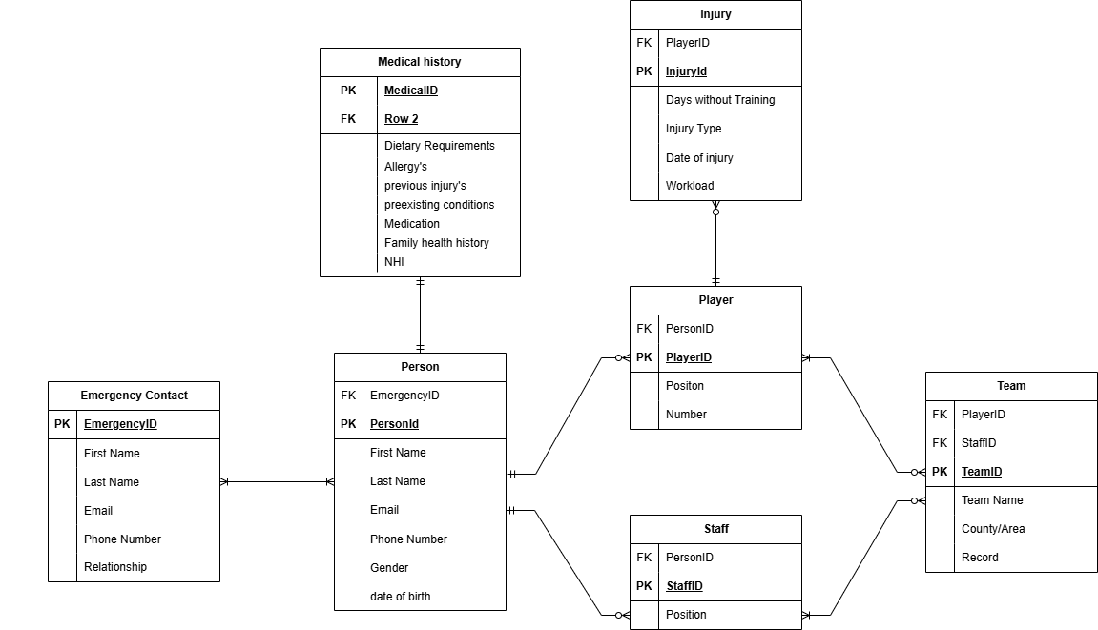
Previous ERD (Not representative of the data we require at all)
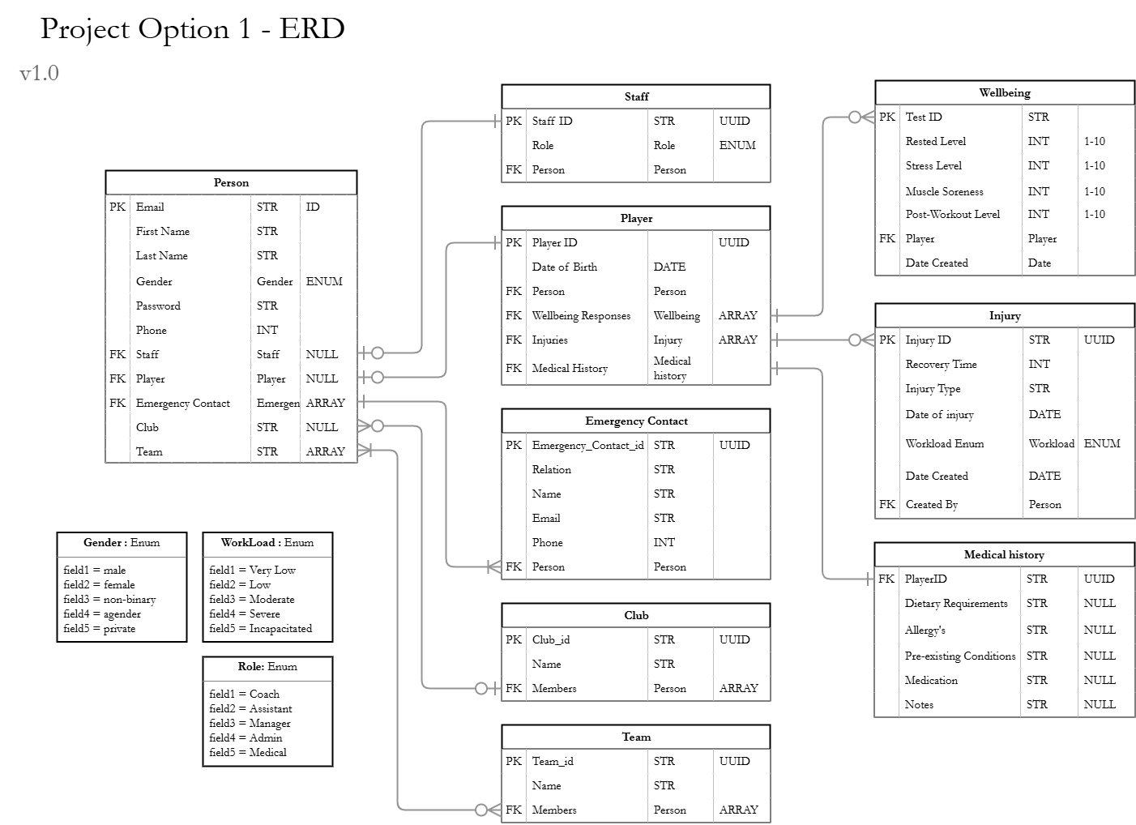
Current logical ERD with enumerators, links and references between each entity.
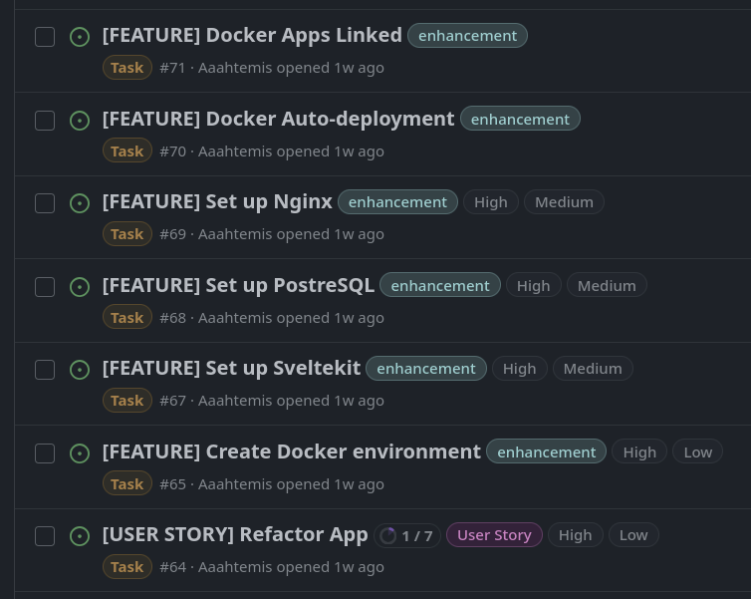
A series of tasks from a user story that represents the requirements set by the product owner.
https://github.com/BIT-Studio-4/ProjectOption1/issues?q=is%3Aissue%20state%3Aopen%20author%3AAaahtemis

  - Participate regularly in code/solution review to ensure high-quality outputs

Evidence guidance: Have you conducted a review of someone else’s PR every Sprint? Can you show at least one example where you helped to improve the quality of the feature with your feedback? Have you written a report that details the current quality of the team or project with regards to your “champion” role and outlined ways to improve that the whole team can follow?

I’ve written a report of the current project via the audit and discussed appropriate security etiquette with the team.

Unfortunately I haven’t had much to do in the ways of code reviewing as we’ve been restructuring the site over the last few sprints and weren’t pushing code/ requiring a pull request for every issue assigned.
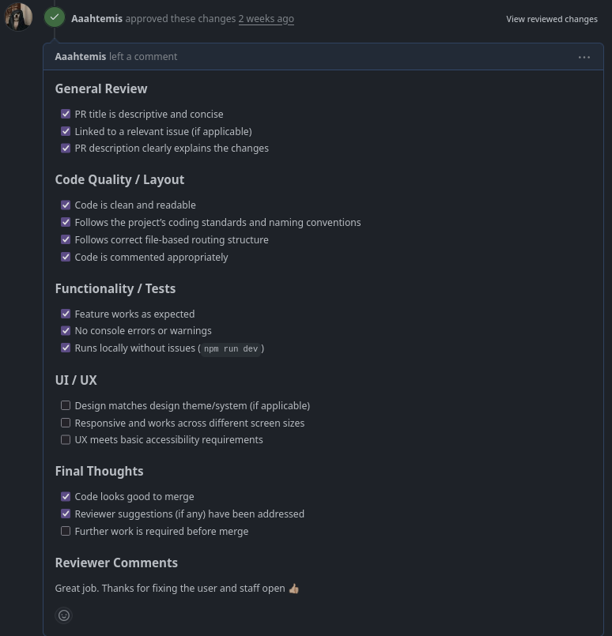
https://github.com/BIT-Studio-4/ProjectOption1/pull/46#pullrequestreview-4965581673

  - Conduct self-directed research to contribute regularly to all technical aspects of the project, including:
  - deployment and CI/CD,
  - quality assurance and testing,
  - security, and
  - user experience.

Evidence guidance: Have you taken your “champion” role seriously, by overseeing that aspect and ensuring everyone in the team contributes (if your role is Scrum Master then you probably answered this in a previous objective)? Have you contributed to all of the aspects listed above in almost every Sprint, in addition to your development work? Have you written tests to go with your code? Have you explicitly checked for security issues and UX issues in code reviews? Have you used the deployment pipeline correctly (e.g. feat. -> staging -> main)? Did you write any automation scripts? Have you employed any specific UX techniques?

